# 

**2026 PARTNERS IN CONSERVATION GRANTS HANDBOOK**

2024 PIC grantee Lower Columbia Estuary Partners take students for one of their STEAM paddles.

**East Multnomah Soil & Water Conservation District**

**Applications Due: 4 PM, Tuesday, December 17, 2025.**

[**Submit your application via ZoomGrants - HERE**](https://www.zoomgrants.com/zgf/EMSWCD/2026_Partners_in_Conservation_PIC)

**Table of Contents**

**Partners in Conservation Grant Guidelines** 3

Important Dates 3

Staff Contact Information 3

Who Can Apply 3

Non-discrimination Policy 4

Grant Requirements 4

Ineligible Entities and Project Types 4

**PIC 2026 Grant Goals and Examples** 5

PIC Grant Program Goals 5

Eligible Project Types 6

**Application Review and Requirements** 7

Grant Application Review Committee 7

Project Requirements and Limits 7

Match Funding 7

Application Review and Award 8

Contract and Payment 8

Insurance Coverage 8

**APPLICATION INSTRUCTIONS & SUPPORT** 9

Application Assistance 9

Language Translation 9

Online Application 9

Working In ZoomGrants 10

**Funding Schedule and Due dates** 11

Staff Contact Information 11

# **Partners in Conservation Grant Guidelines**

The Partners in Conservation (PIC) Grant Program funds community projects that:

* Protect and improve soil health and water quality
* Reduce climate impacts and help communities adapt
* Support sustainable farming and gardening with strong conservation practices
* Provide conservation education
* Restore fish and wildlife habitat

These grants increase conservation benefits for communities and populations experiencing disparities in environmental health, environmental education, and natural amenities.

Grant Size: $10,000 – $80,000

Project Length: Up to 2 years.

## **Key Dates**

* October 15, 2025 – Applications open
* December 17, 2025, 4 p.m. – Applications due
* February – March 2026 – Grant Review Committee meets
* April 2026 – Awards announced
* June 2026 – Projects may begin (with signed agreement)
* June 1, 2026 – Upfront payments available (with signed agreement)

## 

## **Staff Contact Information**

Heather Nelson Kent at [heather@emswcd.org](mailto:Heather@emswcd.org) 503-935-5370. Or visit [emswcd.org/grants](https://emswcd.org/grants-and-cost-share/).

## **Who Can Apply**

Your project must take place within East Multnomah County (east of the Willamette River). See project boundary here <https://emswcd.org/about/#district>

Eligible applicants include:

* Community-based organizations with nonprofit status; 501(c)(3) tax-exempt organizations.
* Community groups without non-profit status may apply for an EMSWCD grant with a fiscal sponsor. A fiscal sponsor is an eligible non-profit organization that provides organizational infrastructure, insurance coverage and administrative support for managing a grant. If a group has neither federal tax exemption nor a fiscal sponsor, [please contact us before applying](mailto:heather@emswcd.org).
* Government agencies or educational institutions.
* Native American tribes or local Indigenous community groups.

**Submit your application online starting October 15, 2025 via ZoomGrants.**

## <https://www.zoomgrants.com/zgf/EMSWCD/2026_Partners_in_Conservation_PIC>

## **Non-discrimination Policy**

If you receive a grant, you must follow EMSWCD’s non-discrimination policy. This means you cannot discriminate based on race, color, national origin, age, disability, sex, religion, sexual orientation, income, or political beliefs. More [here](https://emswcd.org/about/nondescrimination/).

## **Grant Requirements**

* Must be located within EMSWCD’s service area (Multnomah County lying east of the Willamette River centerline) or demonstrate direct benefit to EMSWCD residents. Click here for [more information about the district](https://emswcd.org/about) and a map showing our district boundary.
* Grantees (and/or their fiscal sponsors) are required to carry insurance coverage and are responsible for the proper use, accounting, and reporting of grant funds. EMSWCD reports grant distributions to the IRS.
* Must advance the mission of the EMSWCD “To Help People Care for Land and Water.”
* Must address one or more of the Grant Program Goals (p. 5).

## **Not Eligible**

* Private businesses and landowners (technical help and financial support may be available from other EMSWCD programs).
* Rainwater harvesting systems or cisterns (unless those components are incidental and subordinate to a larger project).
* Buildings and capital projects (unless these components are incidental and secondary to a larger project).
* Capital campaigns.
* Political campaigns.
* Required mitigation projects.

# **PIC Grant Goals and Examples**

## **Partners in Conservation Grant Program Goals**

1. Complement other EMSWCD program efforts in water quality, soil health, fish and wildlife habitat and sustainable agriculture.
2. Increase conservation benefits for communities and populations experiencing disparities in environmental health, environmental education, and natural amenities.
3. Build resilience to climate change in local communities, mitigate climate change impacts, and build momentum for climate change action.
4. Establish school and community gardens that support sustainable and culturally appropriate agriculture practices.
5. Prepare residents for careers or education in natural resources, agriculture, nature education, or other nature-related fields by supporting mentorship, youth programs, and job skill development.

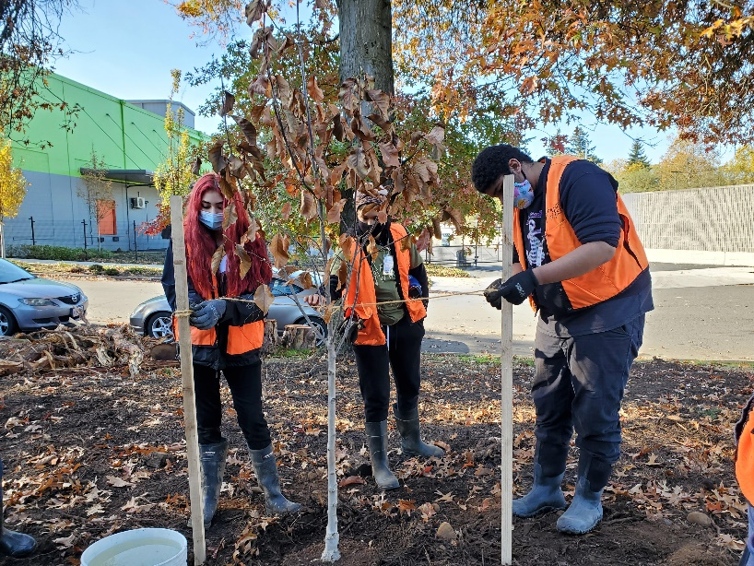

Student Crew Leaders from Rosemary Anderson High School planting trees in Montevilla. Participants receive job training through the Portland Opportunities Industrialization Center. Photo courtesy of PIC grantee POIC.

In 2025, we awarded 29 organizations   
$1.3 million in grants including several   
first-time applicants.

A mix of community-led projects serving   
diverse communities, youth, and families   
received funding.

**[Read about the grants the district funded last year.](https://emswcd.org/community-grants/2025-pic-grant-recipients/)**

## **Eligible Project Types (examples, not a complete list)**

* **On-the-ground restoration or conservation**Examples: stream bank planting, fish and wildlife habitat restoration, weed control.
* **Sustainable agriculture or gardening**Examples: school or community gardens, orchards, native gathering gardens, composting, and irrigation systems. Must show use of conservation practices beneficial to pollinators, soil health, and water quality and/or conservation.
* **Water quality projects**Examples: bioswales in parking lots, rain gardens, tree planting, stream restoration, trash cleanups.
* **Hands-on learning about soil health, water, wildlife, and climate change**Examples: nature education, farm and garden education, workshops, classroom programs, trainings, educational signs.
* **Expanding equitable access to conservation and sustainable agriculture**Examples: programs designed for communities of color or other historically marginalized groups, restoring cultural and community land care traditions.
* **Climate resilience for underserved communities**Examples: community projects that increase access to sustainable and culturally relevant food and plants and/or reduce climate impacts such as extreme heat or flooding.
* **Planning, design or engineering of conservation projects**Examples: natural area restoration projects, soil erosion control designs, stream or fish passage projects, and in-stream habitat improvements.
* **Maintenance and monitoring projects**Examples: tree watering and mulching, improvements to soil and water benefits of established community gardens, tree canopy surveys, testing the effectiveness of weed or sediment controls, and water quality monitoring.

**Priority populations for EMSWCD grants:**We prioritize people with low incomes, communities of color, and other historically marginalized communities for EMSWCD grants. Historically, these populations have had less access to land and the benefits of conservation investments. At the same time, these communities are more vulnerable to extreme heat, wildfire smoke, vector-borne diseases, flooding, and other climate-related impacts.

# **Application Review and Requirements**

## **Grant Application Review Committee**

The EMSWCD Board of Directors appoints a [Grant Review Committee](https://emswcd.org/community-grants/partners-in-conservation-pic-grants/pic-review-application/) to review all Partners in Conservation (PIC) grant applications and recommend projects for funding. This committee includes community members with diverse backgrounds and experience in areas such as conservation, farming, education, social justice, and cultural programming. Up to two EMSWCD board members may also serve on the committee. The EMSWCD Board makes the final decision on all grant awards.

Learn more about last year’s Grant Review Committee members [**here**](https://emswcd.org/about/committees/#pic).

## **Project Requirements and Limits**

* 2026 PIC grants can fund projects lasting up to two years.
* Grants range from $10,000 to $80,000.
* Up to 15% of the budget can be for administrative/indirect costs.
* Each organization may submit only one application but can partner on others.
* Organizations with an existing PIC grant must be in good standing (reports and reimbursements up to date) to apply again.

## **Match Funding**

Match funding allows EMSWCD funds to go farther and demonstrates community support for organizations that are applying for these grants. EMSWCD also recognizes that requiring match funding places a burden on organizations, which may limit their ability to implement projects. **EMSWCD provides flexible match funding requirements. See details in the table below.**

|  |  |  |
| --- | --- | --- |
| **Match Not Required** | **Match Required** | **Match Exception/Waiver** |
| Applications requesting $10,000 or less. | Applications requesting $10,000 or more.   * Applicants are expected to secure matching funds **equal to** the amount requested from EMSWCD. *Overmatching funds are not used in the evaluation of grant applications.* * This match may include cash, in-kind contributions, funding from other sources, or a combination thereof. The grantee will be required to document match funding and track expenditures. | Applications requesting $10,000 - $30,000, AND the applicant meets **one** of the following criteria:   * Organization has been in operation for less than three years, OR * Organization has not received a PIC grant before, OR * The organization’s annual operating budget is less than $250,000. |

## 

## **Application Review and Award**

* Once applications are received, EMSWCD Grants Program staff review all grant applications to confirm eligibility and alignment with EMSWCD grant program goals and criteria and check for completeness.
* A review committee made up of members of the EMSWCD Board and community representatives reviews and ranks the PIC applications and recommends projects for funding to the EMSWCD Board.
* Applicant and project eligibility, approval or denial of applications, and dollar amounts awarded will be determined at the discretion of the EMSWCD Board of Directors. Decisions made by the Board of Directors are final.

## **Contract and Payment**

## If your proposal is funded, EMSWCD will issue a written grant agreement outlining responsibilities, reporting and monitoring requirements, payment procedures, and more. No expenses will be paid or reimbursed before the agreement is signed by both parties.

## Grants may be paid either upfront or on a reimbursement basis. In both cases, documentation (e.g., payroll records, bills, or receipts) is required.

## Grantees may request up to 50% of the total grant amount upfront. All spending from upfront payments must be documented before additional funds are released.

## Grantees must report their match funding sources (up to the 1:1 requirement) but do not need to submit receipts unless requested. However, all match documentation must be retained for possible review or audit.

## EMSWCD may withhold 10% of the grant until the final project report is submitted and approved.

## Payments of $600 or more in a calendar year may be considered taxable income. Grantees must complete an IRS W-9 form, and EMSWCD may issue a 1099-MISC. Applicants should consult a tax advisor regarding reporting requirements and deductions.

## **Insurance Coverage**

EMSWCD requires that grantees provide proof of insurance coverage for the duration of their grant-funded activities. If you or your fiscal sponsor do not currently have insurance, grant awards can be used to purchase coverage and should be included in your application’s proposed budget.

# **APPLICATION INSTRUCTIONS & SUPPORT**

## **Application Assistance**

***Need assistance?***

*Contact our Grant   
Program Manager,   
Heather Nelson Kent at* [*heather@emswcd.org*](mailto:heather@emswcd.org). *Call 503-935-5370.*

Do you need help writing a grant application or putting together a budget? We are here to help! Staff do not participate in the application ranking process with the Grant Review Committee. It’s our job to help you make your application as strong as possible.

We hold online information sessions each year. [Check the program webpage for details](https://emswcd.org/grants-and-cost-share/apply/for-organizations-pic/) and find recordings of these sessions. Contact EMSWCD staff to discuss your ideas – **especially if you are a first-time applicant.**

## **Language Translation**

EMSWCD accepts applications in languages other than English. To request materials in a different language or individual assistance with the help of an interpreter, please contact Heather Nelson Kent at [heather@emswcd.org](mailto:heather@emswcd.org).

## **Online Application**

* Applicants will need to create a login at [zoomgrants.com](https://www.zoomgrants.com/)
* The 2026 grant application will be open between October 15 and December 17 (4 p.m.) 2025.
* Once you submit your application, an email will be sent via ZoomGrants confirming your application was received.
* Make sure you receive notices from ZoomGrants by

adding [notices@zoomgrants.com](mailto:notices@zoomgrants.com) to your safe senders list.

[**Submit your application via ZoomGrants**](https://www.zoomgrants.com/gprop.asp?donorid=2245&limited=5428)

## **Working In ZoomGrants**

* The person who starts an application in ZoomGrants is the “Primary Applicant.” They can invite others as collaborators, but only the Primary Applicant can submit the application.
* ZoomGrants saves responses automatically when you click outside a text field (watch for the “saving” pop-up).
* Character limits (including spaces) help keep applications concise.
* If pasting text from another program (e.g., Word), use “paste as plain text” to avoid formatting errors that may block submission.
* For help, use the Help button in ZoomGrants or email questions@zoomgrants.com.

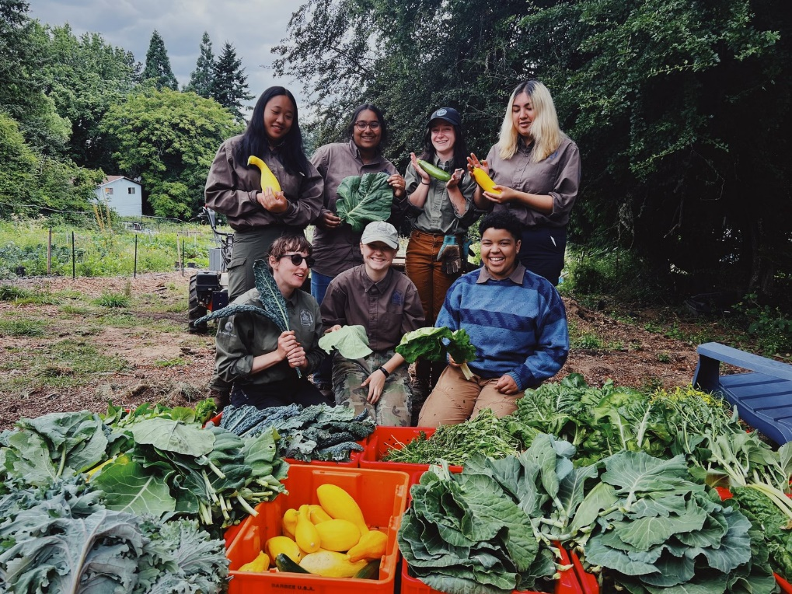

Volunteers show off the harvest. Photo courtesy of Kindness Farm, PIC Grantee.

# **Funding Schedule and Due dates**

## **Key Dates**

* October 15, 2025 – Applications open
* December 17, 2025, 4 p.m. – Applications due
* February – March 2026 – Grant Review Committee meets
* April 2026 – Awards announced
* June 2026 – Projects may begin (with signed agreement)
* June 1, 2026 – First payments available (with signed agreement)

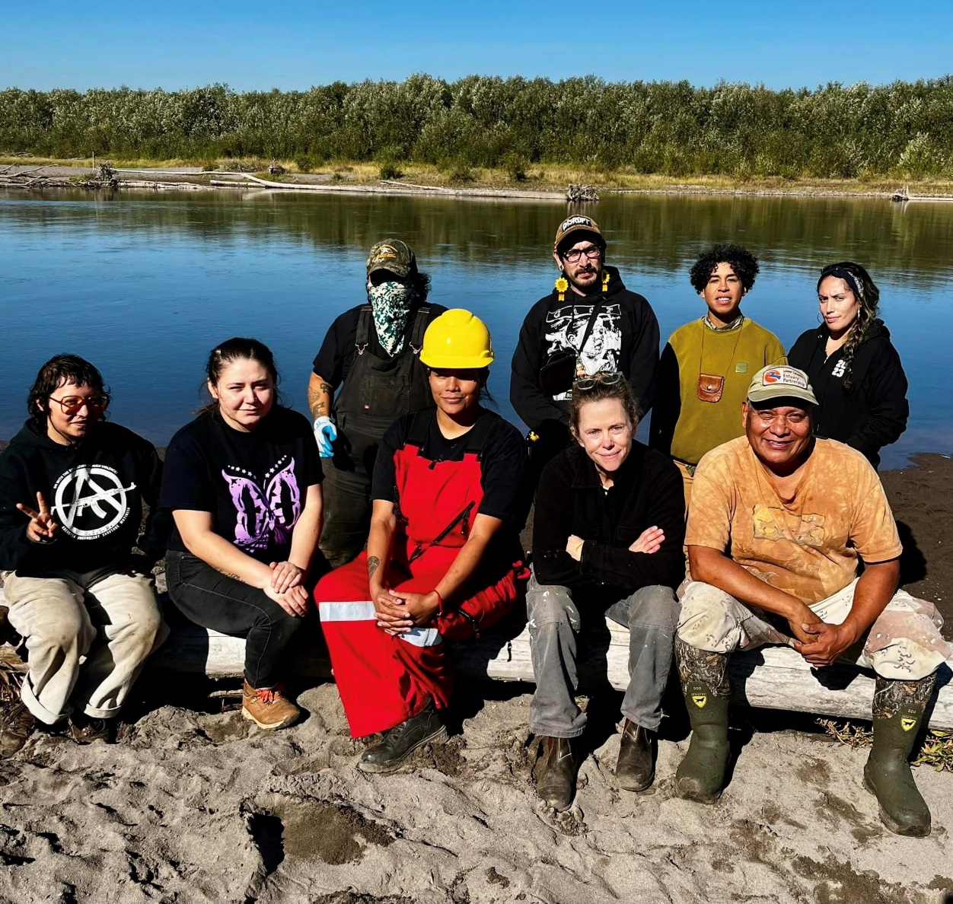

Interns from Wisdom of the Elders, photo courtesy of Confluence Project, PIC Grantee

## 

## **Staff Contact Information**

For more information, please visit emswcd.org/grants or contact Grant Program Manager Heather Nelson Kent at [heather@emswcd.org](mailto:Heather@emswcd.org). Call Heather at 503-935-5370.