For Immediate Release
February 24th, 2016

Contact:
Rick McMonagle
Rick@emswcd.org
(503)935-5374
http://emswcd.org/

What Does the Future Hold for Your Farm? – Free workshop on the legal, financial, and business factors to consider when planning for a farm’s future.

The East Multnomah Soil and Water Conservation District (EMSWCD) is hosting a free Farm Succession workshop from 6:00pm – 9:00pm on Monday March 14th, 2016 at the Holiday Inn Express in Troutdale. Participants will learn about the options available to them as they prepare to transition their working lands to future generations.
The average farmer in Oregon is now over 59 years old and many families are facing transition to a younger family member or another farmer. There are many important issues to be aware of when considering a property transfer. Can the current owners afford to retire? Do the younger generations want to keep farming? How do you transfer the farm’s assets? Speakers will help answer these pressing questions.
Featured speakers include: Jay McRostie, attorney specializing in business, estate planning, and real estate transactions; Tamara Cushing, Ph.D. and Extension Specialist in Forest Economics, with expertise in succession planning for landowners; Mel Omeg, former owner/operator of Omeg Orchards; and Jay Udelhoven, EMSWCD Executive Director. They will discuss the legal, financial, and business factors to consider as landowners prepare to transition their working lands to future generations, as well as share some of the resources available to assist farmers with farm succession. Participants will be presented with real world examples of how to address these important and often complicated issues.
Where: Holiday Inn Express, 477 NW Phoenix Dr. Troutdale, OR 97060
When: Monday March 14th, 2016. 6:00pm – 9:00pm

The East Multnomah Soil and Water Conservation District (EMSWCD) is a unit of local government whose mission is to help people care for land and water. The EMSWCD is led by an elected board of five directors and works entirely on a voluntary, non-regulatory basis with landowners, land managers, and other residents east of the Willamette River centerline in Multnomah County. All of the EMSWCD’s work is geared toward keeping water clean, conserving water and keeping soil healthy.
Contact Rick McMonagle, Land Legacy Program Manager, with any questions about the Farm Succession Workshop at rick@emswcd.org or (503) 935-5374. Learn more about us at http://emswcd.org
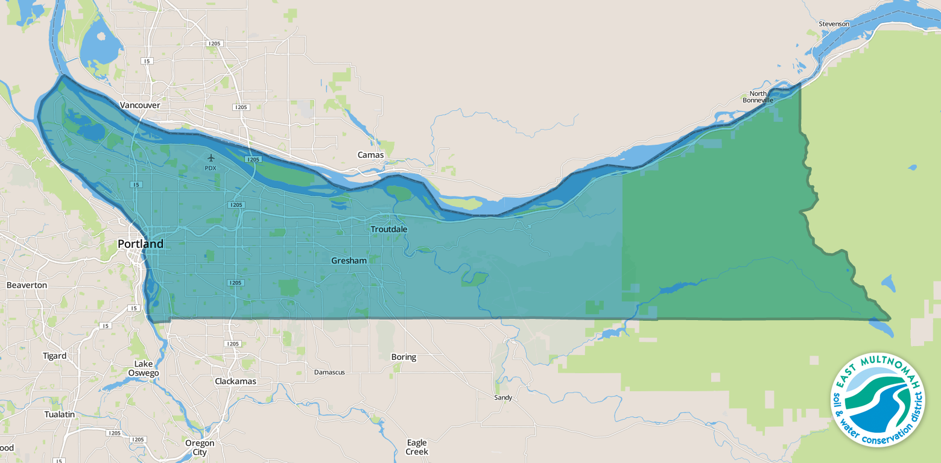

Map of EMSWCD District area, which is all Multnomah County East of the Willamette River.

###

