FOR IMMEDIATE RELEASE:

CONTACT:
Rick McMonagle, Land Conservation Legacy Program Manager
East Multnomah Soil & Water Conservation District
Phone: W 503-935-5374
C 971-271-9281
Email: rick@emswcd.org
Fax: 503-935-5359
www.emswcd.org

Fairview Creek Headwaters Permanently Protected

PORTLAND, OREGON, May 29, 2014- East Multnomah Soil and Water Conservation District (EMSWCD), Metro and the City of Gresham have purchased and permanently protected the Headwaters of Fairview Creek and Grant Butte Wetlands for wildlife habitat and public open space. This significant acquisition includes over 1/3 mile of Fairview Creek, a portion of Grant Butte, habitat for about one hundred species of wildlife, and a very essential block of natural open space for the residents of East Portland and the City of Gresham. Metro and Gresham will manage the property.

“We are really excited that we were able to partner with Gresham and Metro to permanently protect this amazing resource for the community," said Board Chair Laura Masterson. “These types of partnerships are critical to preserving nature in our neighborhoods."

There has been a lot of recent media attention concerning the lack of parks and open space for residents in this part of the metropolitan area. This property, located on NW Division Street near 190th Avenue, will help to address this deficit. “This is a huge win for wildlife and for water quality. It is also a huge win for the neighborhood which currently lacks access to nature but will soon have a premier natural area in its midst,” said District Director, Bob Sallinger.

This is an area rich in wildlife, including sensitive amphibian and reptile species that are present within the Fairview Creek system and are known to be present on public parcels near this new acquisition area. One of the only known breeding populations of Western Painted Turtles east of the Willamette River in Oregon is found near the new acquisition area.

This acquisition also protects part of Grant Butte, one of the remaining “emerald islands” of nature in the east metropolitan area. As our urban populations grow and the surrounding lands become more developed, protecting these vital natural areas will be ever more important.

For additional information contact:
Rick McMonagle, EMSWCD, at 503-935-5374 or 971-271-9281
Steve Fancher, City of Gresham, at 503-618-2525
Dan Moeller, Metro, at 503-797-1819

ABOUT EAST MULTNOMAH SOIL & WATER CONSERVATION DISTRICT – EMSWCD is a non-regulatory, tax funded unit of local government existing to conserve, protect, and enhance soil, water, air, and other natural resources to achieve a healthy environment for the people, fish, and wildlife of Multnomah County east of the Willamette River in both rural and urban settings. All of the programs of the EMSWCD emphasize that individuals can have a positive impact on water quality and wildlife habitat.

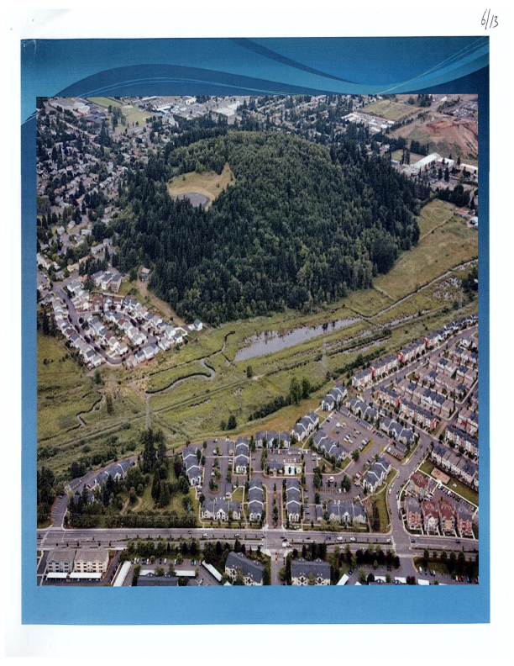
Fairview Creek Headwaters and Grant Butte

#####

